PORTABLE LOW-COST DEVICE FOR EXAMINATION OF VISUAL EVOKED POTENTIALS (VEPs)
- Keywords
Device for VEPs, visual perception, diagnostics, visual and cognitive evoked potentials
Market keywords
Portable device, diagnostics, VEPs equipment, neuro-ophthalmology
NACE keywords
26.6 Manufacture of irradiation, electromedical and electrotherapeutic equipments
32.5 Manufacture of medical and dental instruments and supplies
72.1 Research and experimental development on natural sciences and engineering

- Summary
The Department of Pathological Physiology at Charles University - Faculty of Medicine in Hradec Králové (Czech Republic) has developed and patented a low-cost 4-channel portable device for examination of visual evoked potentials (VEPs). It allows to evaluate visual pathway and central nervous system functions and to diagnose their disorders. With this device, it is possible to carry out VEP diagnostics where needed, including home self-examination, without specialised personnel. The device is about twenty times cheaper compared to the standard VEP equipment. The University is looking for an industrial partner, interested in production of the device.
- Description
The Electrophysiological Laboratory in Hradec Králové has 50 years long tradition in research and diagnostic applications of visual evoked potentials (VEPs) and cognitive potentials. The non-invasive registration of the evoked electrical activity of the human brain during a visual stimulation is used to detect neuro-ophthalmological and central nervous system diseases (e.g. Multiple Sclerosis, Optic Neuritis, Amblyopia, age related visual disorders, encephalopathies, psychiatric disorders) and to monitor their progress or therapeutic effects.

Recently, the Lab has developed a novel low-cost 4-channel portable device for examination of VEPs and visual cognitive potentials, built into the ergonomic headset (carrier enabling positioning of the visual stimuli in various parts of the visual field). So far existing bulky and expensive devices for VEPs examination has been usable only in specialised labs. This significantly limits applications of this method. On the contrary, the new portable device on offer can be simply used in almost any conditions (e.g. for VEP long-term monitoring outside labs).
The portable VEP device consists of a visual stimulator (a matrix of light-emitting diodes with adjustable luminance and colour), producing a large spectrum of monocular or binocular stimuli (including those with a cognitive task) and a recording part (based on a 4-channel EEG amplifiers). Two dry electrodes placed in a fixating belt of the headset record signal from the forehead and two additional recording electrodes can be freely located over an activated part of the brain cortex (according to the used variant of visual stimuli).

The recorded cortical reactions are transmitted via an USB port to a PC for on-line processing, VEP display and their off-line evaluation. The device is equipped with a sensor of the background luminance (allowing an autonomic regulation of the stimulation luminance) and with a 3D accelerometer enabling rejection of the signal contaminated with artefacts caused by examinee’s movements during examination.

- Advantages
- Wide mobility of the device – it can be used where needed (indoor, outdoor), including at home
- Easy handling of the device eliminates need for a specialised staff
- Possibility of a long-term VEP monitoring (even during working activities)
- Low-cost device, it is expected to be much cheaper than available alternatives
- Home monitoring of VEPs enables early detection of changes and hence possibly a prevention of unnoticed significant illness progresses
- The device provides objective information about changes in reactivity of the central system – it can be used not only in the medical sector but also for a needed early detection of fatigue and sleepiness in various professions
- It is simple use, compared to the standard VEP equipment

- Development stage
☐Already on the market ☐Project already started
☐Available for demonstration ☐Project in negotiations- urgent
☐Concept stage ☐Proposal under development
☒Field tested/ evaluated ☐Proposal under development
☐Under development/ lab tested
The 10 identical prototypes of the device are currently tested in over 200 healthy volunteers (12 - 70 years of age) to create norms of VEP parameters for this device and in neuro-ophthalmological patients to verify diagnostic sensitivity of the device compared to the standard VEP examinations.

- IPR status
☐Granted patent or patent application essential ☐Trade Marks
☐Patent(s) applied for but not yet granted ☐Copyright
☒Patents granted ☐Design Rights
☐Secret Know-How ☐Exclusive Rights
☐Other (registered design, plant variety, etc.

- Partner sought

University is looking for an industrial partner interested in manufacturing of this device and its introduction to the market (after obtaining of a license/financial agreement).

- Type of partnership considered

☐Manufacturing agreement ☒Financial agreement
☐Research cooperation agreement ☐Join venture agreement
☐Services agreement ☒Licence agreement
☐Technical cooperation agreement
☒Commercial agreement with technical assistance
- Research Team

Prof. Miroslav Kuba, M.D.,D.Sc.

Assoc. prof. Jan Kremláček, MSc.

František Vít, MSc.

- Team capacity in relation to the project
http://www.patfyzlfhk.cz/elf/

- Gallery
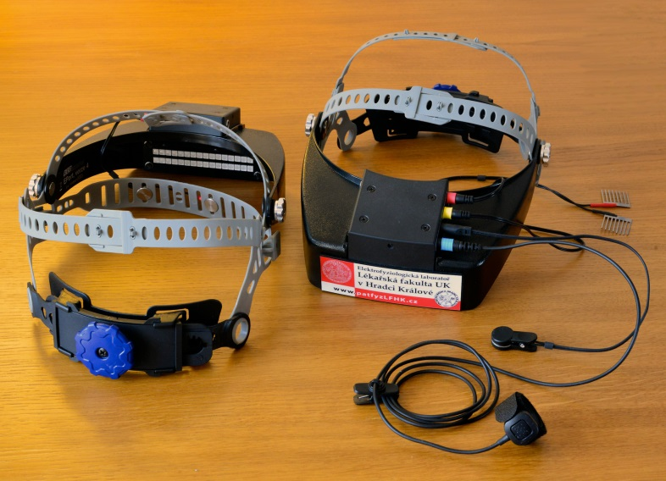
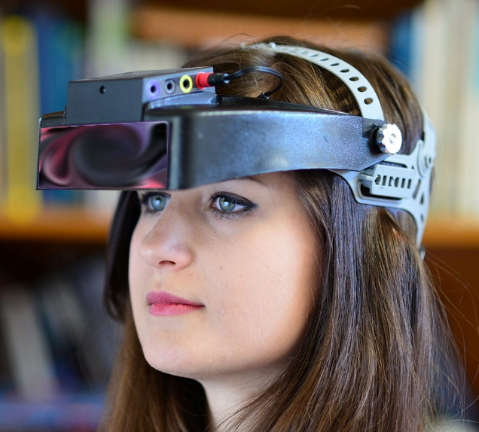

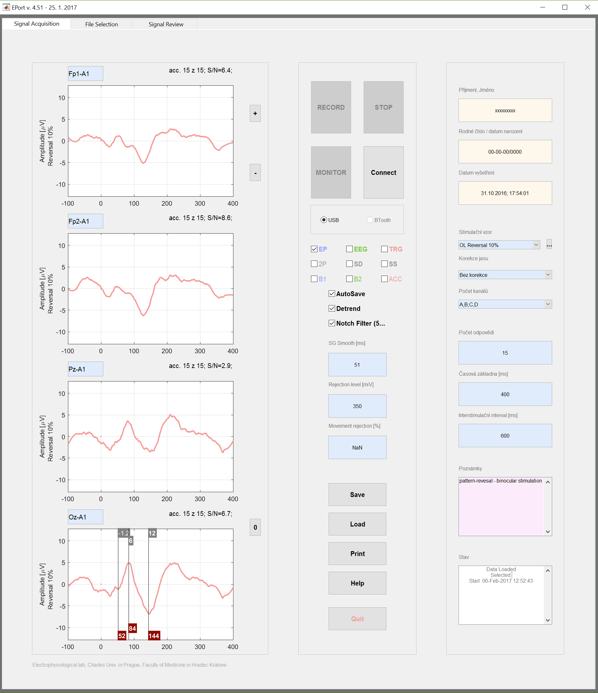

- External links
http://een.ec.europa.eu/tools/services/PRO/Profile/Detail/918ce971-a3c7-47e5-aa16-a4db7bc8b75a?shid=32db25cb-726f-43b0-8b5f-7742d0935799
Publication: https://www.lfhk.cuni.cz/patfyz/vyzkum/elf/pub/
Examination: www.lfhk.cuni.cz/patfyz/vyzkum/elf/vysetreni/

